**Customer churn Report**

**What is Churn?**

**Churn** refers to the percentage of customers who stop using a service within a specific time period. In this context, churn measures how many customers leave the company over a given period (for instance, one month, quarter, or year) and is usually represented as a percentage of total customers. A high churn rate indicates a large number of customers are discontinuing their service, while a low churn rate indicates better customer retention.

**What is Tenure ?**

**Tenure** in this context refers to the **length of time a customer has been with the company** or has been using a specific service. It is essentially the **duration of the customer's relationship** with the service provider.

**Explanation of the Dashboard:**

1. **Total Customers & New Joiners:**
   * **Total Customers (6418):** Represents the total number of customers currently using the service.
   * **New Joiners (411):** Indicates the number of new customers who have recently signed up.
2. **Churn Rate & Total Churns:**
   * **Churn Rate (27%):** Shows the percentage of customers who have left the service.
   * **Total Churns (1732):** The number of customers who have churned (left) the service.
3. **Churn Rate by Demographics:**
   * **Gender:** Males have a higher churn rate (31%) compared to females (24%).
   * **Age Groups:** Churn rate is higher among older age groups (50+), indicating a need for targeted retention strategies.
4. **Churn Rate by Region:**
   * **Top 5 states with the highest churn rates:** Jammu & Kashmir, Assam, Jharkhand, Chhattisgarh, Delhi – regions with higher churn, suggesting region-specific strategies may be required.
5. **Churn Rate by Paper Method:**
   * Customers receiving **mailed bills** have a higher churn rate (37.8%) compared to those who receive communication through **bank/wire** (34.4%) and **credit** (14.8%).
6. **Churn Rate by Contract Type:**
   * **Month-to-Month contracts** have the highest churn rate (46.5%) compared to **One-Year** and **Two-Year contracts**, where churn rates are significantly lower.
7. **Churn Rate by Tenure:**
   * **6-12 months** of tenure have the highest churn rate (27.2%).
   * Churn rate decreases for customers with **longer tenure** (24+ months).
8. **Churn Rate by Service Category:**
   * **Multiple Lines** and **Internet Services** have the highest churn rates (54.7% and 93.4%, respectively).
   * **Device Protection Plans** show a lower churn rate (28.5%), suggesting these services are better retained by customers.

**Insight #1**

**56% churn rate in Jammu & Kashmir**

1. **Observation**:
   * Jammu & Kashmir has the highest churn rate.
   * Most of the churns in that region come from **female customers**.
2. **Suggestion**:
   * **Investigation of Female-Specific Problems**:  
     To address the high churn rate among female customers, understanding what specific issues they face can be crucial. This could include problems related to service dissatisfaction, customer support, or regional-specific challenges like internet quality, billing concerns, or accessibility issues.
   * **Targeted Interventions**:
     + Conduct surveys or feedback sessions with female customers to gather insights into their experiences.
     + Address concerns such as service quality, communication, or any other pain points identified through these interactions.

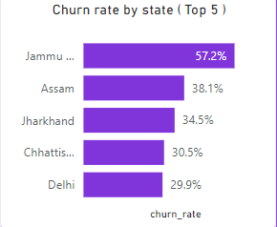

**Insight #2**

**Observation:**

* Customers with **Month-to-Month contracts** have the **highest churn rate (46.5%)** compared to One-Year (11%) and Two-Year (2.7%) contracts.

**Insight:**

* Customers on flexible contracts are less committed and more likely to churn. Long-term contracts show significantly lower churn rates, indicating customer loyalty improves with longer agreements.

**Suggestions:**

* Introduce **incentives or discounts** to encourage customers to switch from Month-to-Month contracts to longer-term plans.
* Offer benefits such as **loyalty rewards** or bundled services for long-term contract customers.

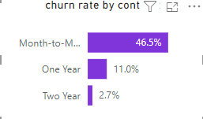

**Insight #3: Competition is the Main Reason for Losing Customers**

**Observation:**

* **Churn rate and churn count** have increased due to a highly competitive market.
* **761 customers** have churned because they found **better services** from competitors.

**Suggestions:**

1. **Offer New Plans and Features:**
   * Create **attractive plans** (e.g., cost-effective bundles, discounts, or loyalty rewards) to match or exceed competitor offerings.
   * Introduce **flexible plans** with customizable options to suit diverse customer needs.
2. **Innovate Beyond Competitors:**
   * Develop **unique features or services** that competitors do not offer (e.g., superior customer service, faster issue resolution, exclusive benefits).
   * Utilize **technology advancements** to provide better service quality (e.g., AI-based support, service reliability).
3. **Understand Competitor Strategies:**
   * Conduct **competitor analysis** to understand their:
     + Pricing and plans.
     + Customer engagement strategies.
     + Marketing and promotional techniques.
   * Use these insights to **strategically position your services** to stand out in the market.

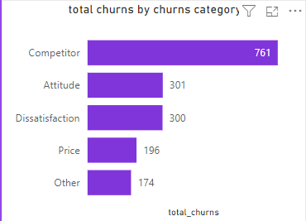

**Insight #4**

**Observation:**

* **Internet Service** has the **highest churn rate** (93.4%), meaning a significant number of customers are dissatisfied with their internet connection.
* Services like **Device Protection Plan** (71.02%), **Online Security** (84.64%), and **Phone Service** (90.5%) also show high churn.

**Suggestions :**

**Improve Core Service Quality**:

* **Internet Service** and **Phone Service** churn needs immediate attention:
  + Improve **network reliability** and reduce downtimes.
  + Offer **tiered plans** (e.g., speed-based pricing) to give customers flexibility.
  + Provide better **customer support** to address technical issues quickly

**Leverage Low-Churn Services for Retention**:

* Promote features like **Paperless Billing** and **Premium Support** as value-added benefits to increase overall satisfaction.

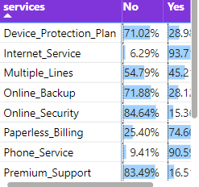

**Insight #5**

**Old age customers have most churn rate**

**Observation:**

* The **50+ age group** has the **highest churn rate (31%)** compared to younger age groups.
* Most of them are from Jammu & Kashmir which contributing 65% in top 5 catergory of old age group

**Insight:**

* Older customers may face challenges related to technology usage, customer support, or service value.

**Suggestions:**

* Provide **personalized support** or educational programs to assist older customers in understanding and using services.
* Offer **senior discounts** or tailored plans to retain older customers.
* Improve communication and outreach to better engage this demographic.

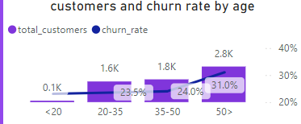

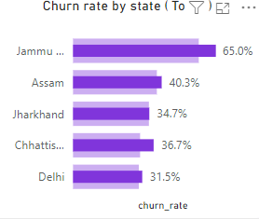

**Insight #6**

**Churn by Internet Type**

**Observation:**

* Customers using **Fiber Optic** have the **highest churn rate (41.1%)** compared to Cable (25.7%) and DSL (19.4%).

**Insight:**

* Despite being a modern and fast option, Fiber Optic users may face issues with **service disruptions**, pricing, or support.
* Fabric optic connection are expensive and not easy to maintain

**Suggestions:**

* Investigate the quality of **Fiber Optic services** (e.g., downtime, speed issues) and resolve them promptly.
* Provide promotional offers or discounts for Fiber Optic users to increase satisfaction.
* Improve customer service responsiveness for Fiber Optic customers.

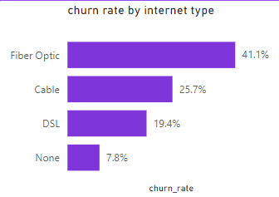

**Insight #7**

**Observation :**

* **Customers with 6-12 months tenure** have the **highest churn rate** of **27.2%**.
* This means **a large number of customers leave within 6 to 12 months** of starting their relationship with the company.

**Comparison with Above 24 Months Tenure**:

* Only **0.3%** of customers churn after more than **24 months** of tenure.
* This highlights that **long-term customers are much less likely to leave** compared to those in their early months.

**Suggestions :**

**Long-Term Customer Retention Programs**:

* Emphasize the **value** of the service to reduce churn for long-term customers.
* Build a trust about service through campaigns and personal support to customers to stick on long term engagement

**Retention Strategies for 6-12 Month Customers**:

* Offer **discounts, upgrades, or exclusive incentives** to keep customers engaged and reduce churn during this critical phase.
* Provide **timely feedback loops** to address concerns and ensure customer satisfaction.

*Summary of all insights*

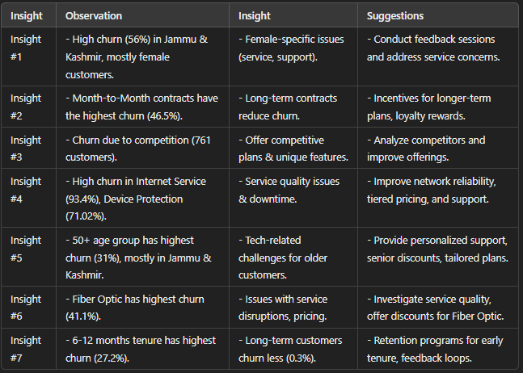

***Conclusion***

The churn analysis highlights key patterns and areas for improvement. Major insights point to high churn rates in specific regions (e.g., Jammu & Kashmir), customer demographics (e.g., female customers, older age groups), and contract types (e.g., Month-to-Month contracts). The primary drivers of churn include competition, service quality, and unmet expectations during early tenure periods.

To reduce churn, organizations should focus on:

1. **Addressing region-specific concerns** such as service quality, customer support, and tailored solutions.
2. **Offering incentives** for long-term contracts and addressing dissatisfaction in early stages.
3. **Innovating beyond competitors** with unique features, improved service quality, and better customer engagement strategies.
4. **Providing personalized support** and targeted solutions for older customers and females, ensuring their specific needs are met.

THANK YOU